LAB TASK NO#1

Problem#1

Write an algorithm and draw the flowchart for finding the average of two numbers.

**Algorithm:**

**Input:** two numbers x and y

**Output:** average of x and y

**Steps:**

1. input x

2. input y

3. sum = x + y

4. average = sum /2

5. output average

START

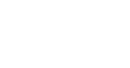

Input x

Input y

Sum = x + y

Average = sum/2

Output

Average

END

Average of two numbers:

**CODE INPUT:**

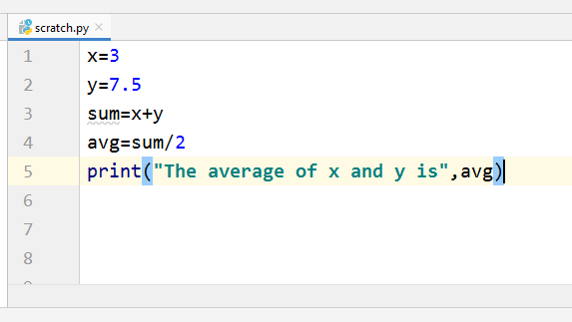

**CODE OUTPUT:**

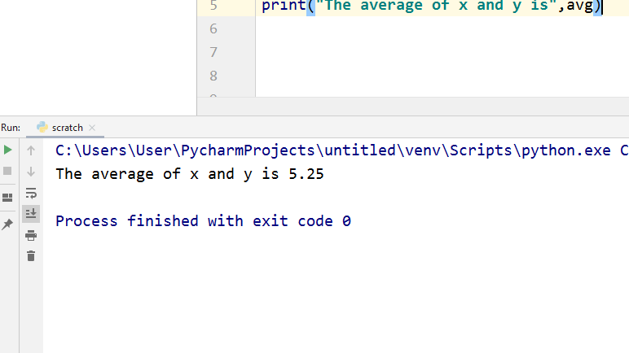

Problem#2

Write an algorithm for finding the area of a rectangle.

**Algorithm:**

**Input:** two numbers length and width

**Output:** area of rectangle

**Steps:**

1. input length

2. input width

3. area=length*width

4. Output area

Start

Input length

Input width

Area=length*width

End

Output Area

Problem#3

Program that tells the person the year he/she will turn 100 years old.

CODE INPUT:

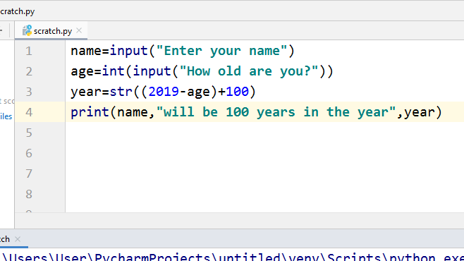

CODE OUTPUT:

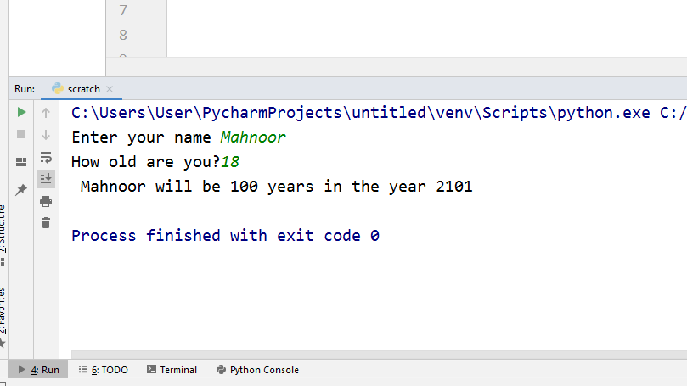

Problem#4

Printing the string in a specific format

CODE INPUT:

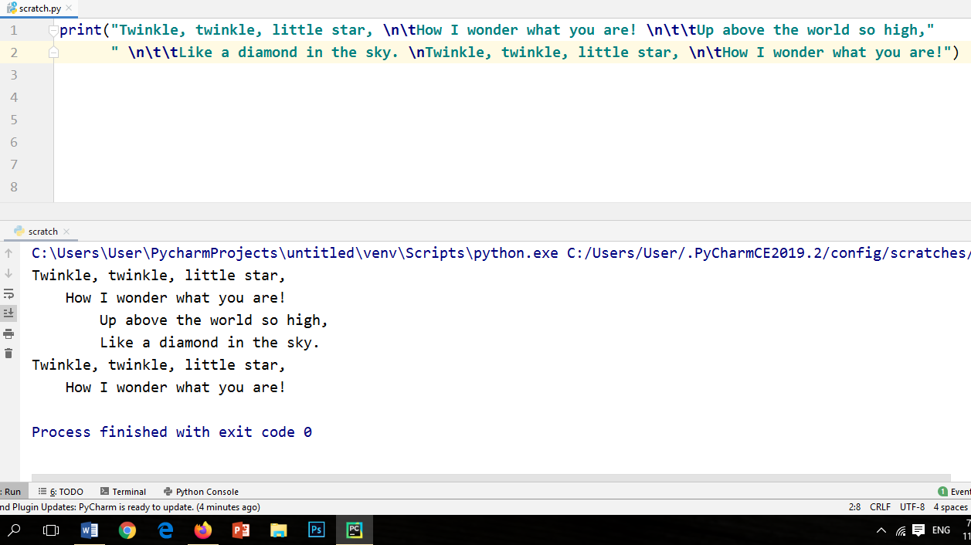

CODE OUTPUT:

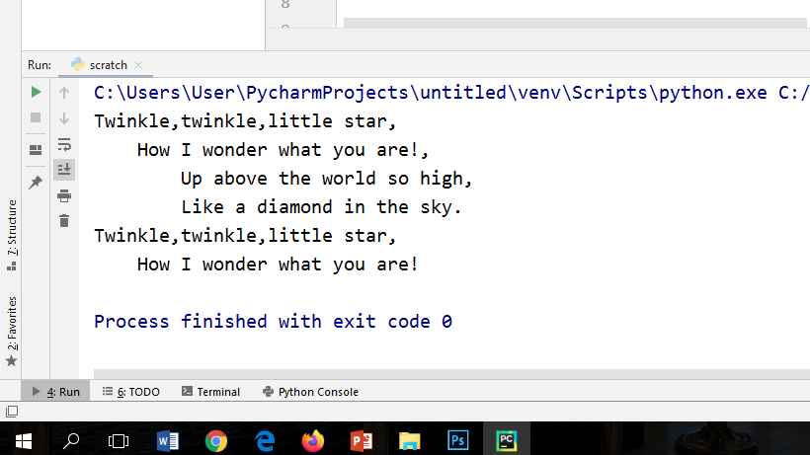

Problem#5

Write a Python program to display the current date and time.

CODE INPUT:

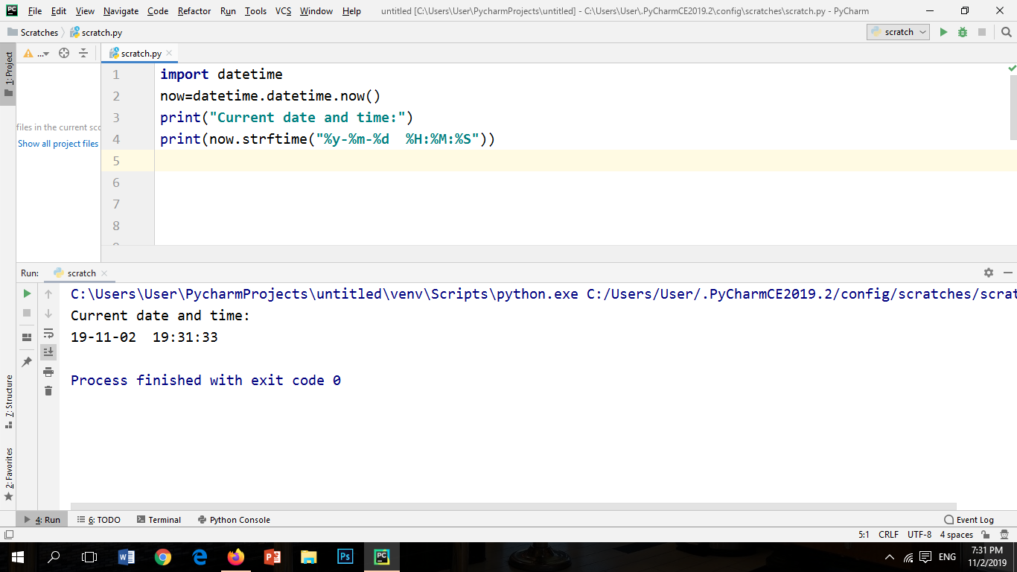

CODE OUTPUT:



Problem#6

Write a Python program which accepts the radius of a circle from the user and compute the area.

CODE INPUT:

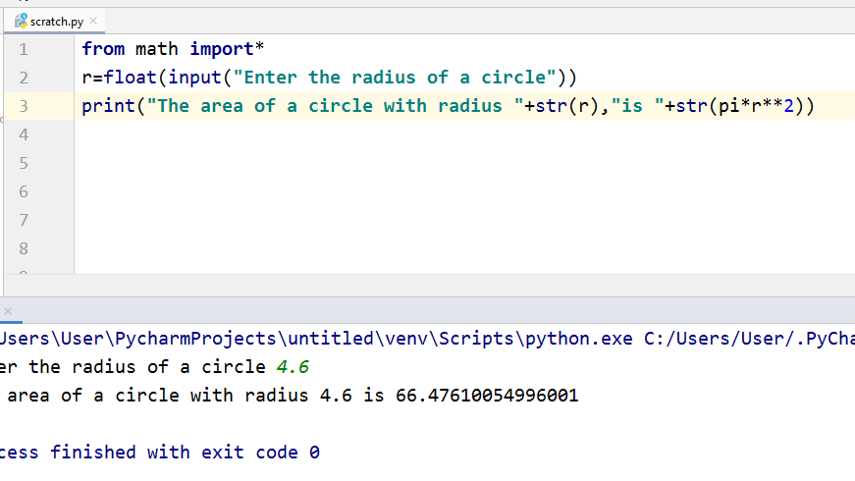

CODE OUTPUT:

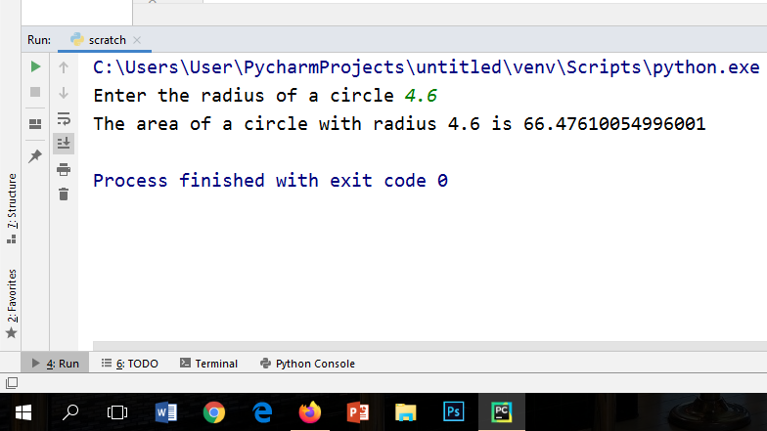

Problem#7

Write a Python program which accepts the user's first and last name and print them in reverse order with a space between them.

CODE INPUT:

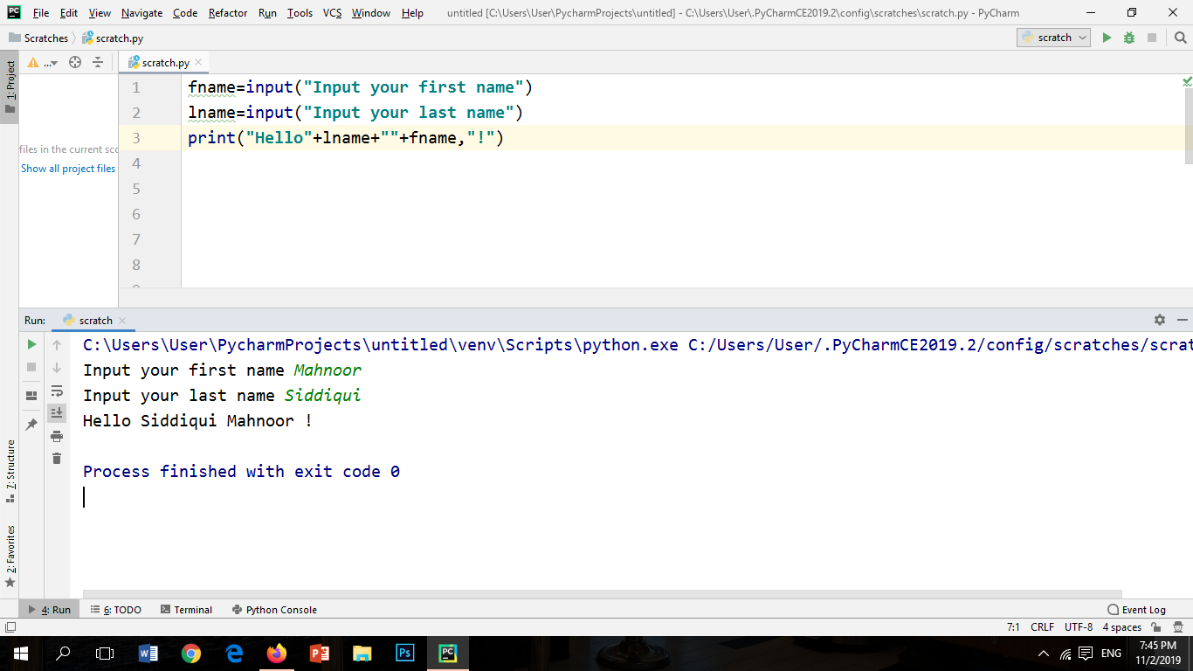

CODE OUTPUT:



Problem#8

Write a Python program to print the calendar of a given month and year.

Note: Use 'calendar' module

CODE INPUT:

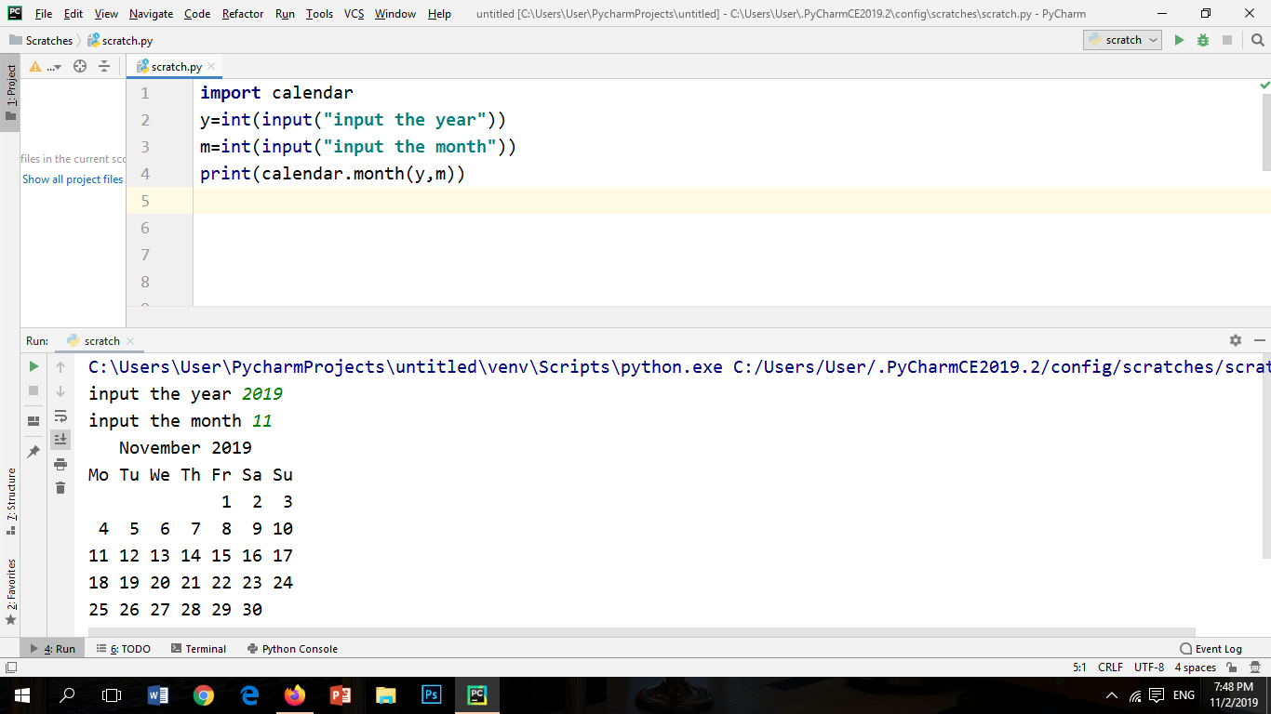

CODE OUTPUT:



Programming exercise#1

1.Write a program for converting Centigrade into Fahrenheit.

CODE INPUT:

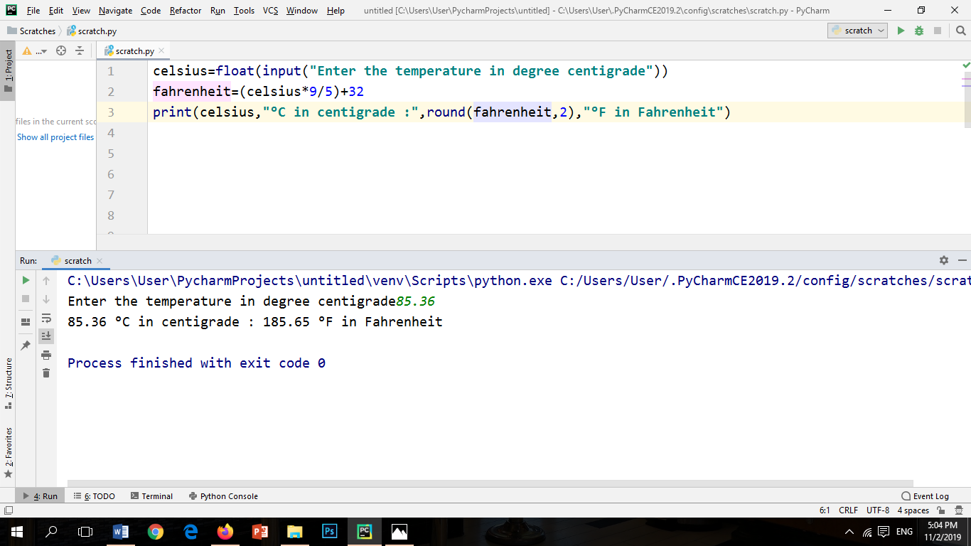

CODE OUTPUT:



FLOWCHART:

Start

Input temperature in

Degree Centigrade

Fahrenheit=(Celsius*9/5) +32

Output Fahrenheit

End

Programming exercise#2

Write a program for converting Fahrenheit into Centigrade.

CODE INPUT:

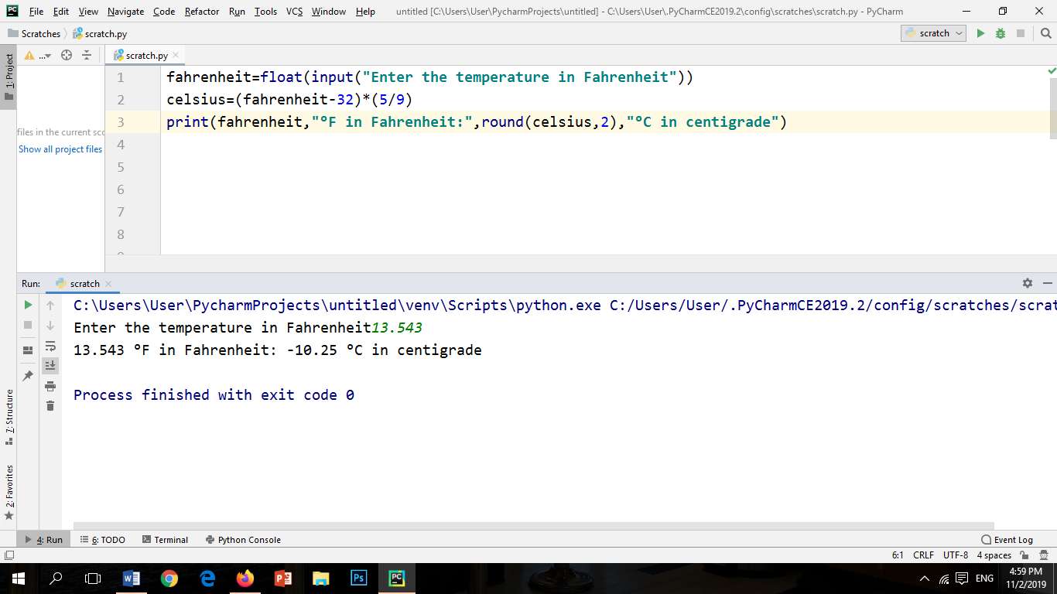

CODE OUTPUT:



FLOWCHART:

Start

Input temperature in

Fahrenheit

Celsius=(Fahrenheit-32) *(5/9)

Output Celsius

End

Programming exercise#3

Write a program to calculate the area of a rectangle.

CODE INPUT:

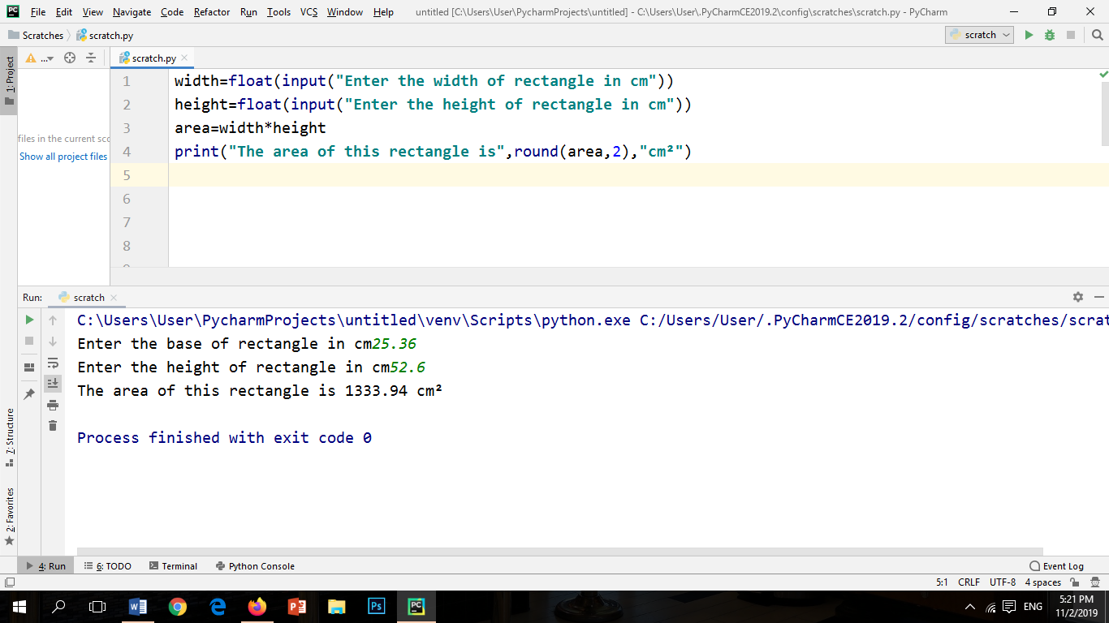

CODE OUTPUT:



FLOWCHART:

Start

Input length

Input width

Area=length*width

End

Output Area

Programming exercise#4

4.Write a program to calculate the volume of a sphere.

CODE INPUT:

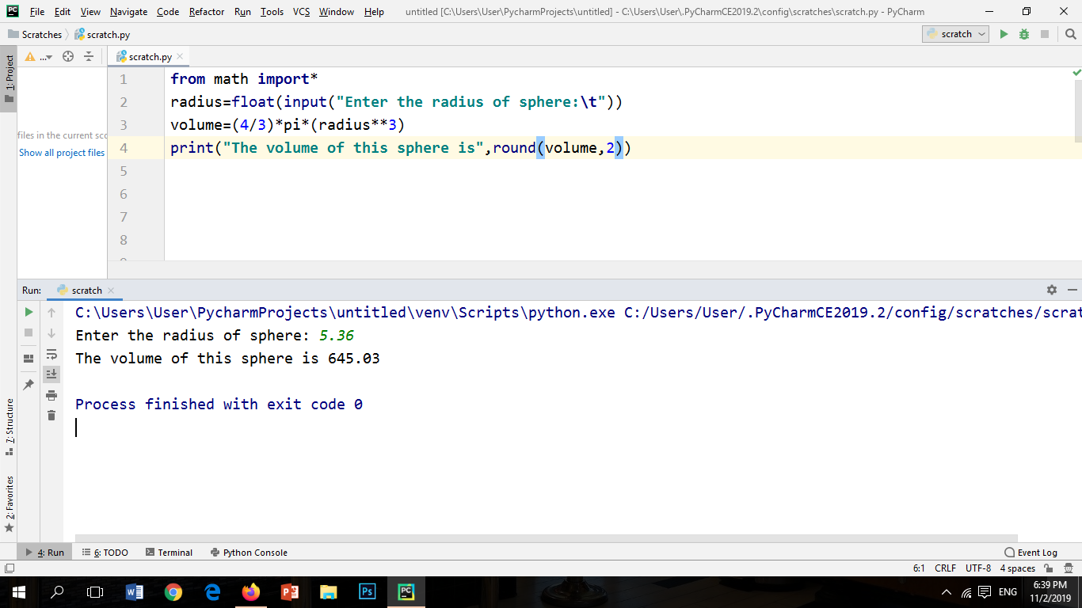

CODE OUTPUT:



FLOWCHART:

Start

Input radius

Volume = (4/3)*pi*radius**3

Output Volume

End

Programming exercise#5

Write a program that can write your name in lower case, upper case and title case.

CODE INPUT:

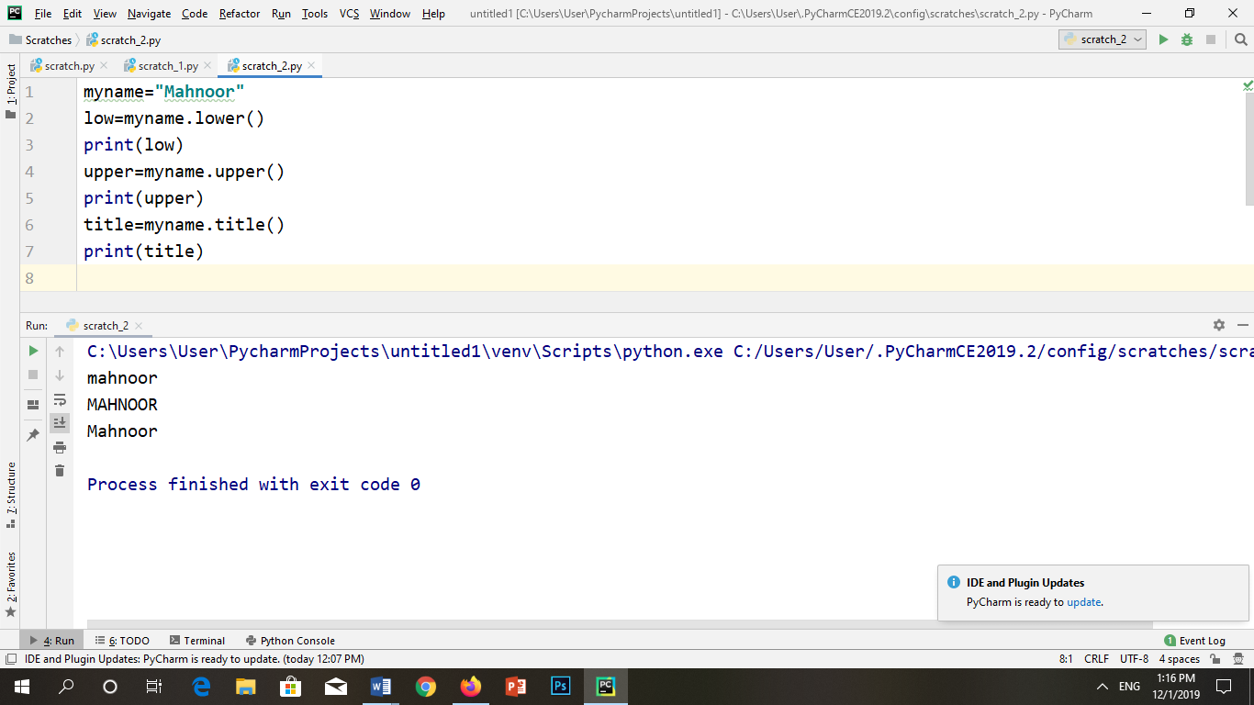

CODE OUTPUT:



FLOWCHART:

Start

Input Name

low=myname.low()

Print low

upper=myname.upper()

Print upper

title=myname.title()

Print title

End